**PRACTISE HTML**

**Lesson 1:** Use Notepad to create the below Web page and save name as **Lesson1.html**

*(Use Heading tag, Set background color for page is Green, text color is red)*



**Lesson 2:** Use Notepad to create the below Web page and save name as **Lesson2.html**



**Lesson 3:** Use Notepad to create the below Web page and save name as **Lesson3.html**



**Lesson 4:** Use Notepad to create the below Web page and save name as **Lesson4.html** *(Use OL and UL tag)*



**Lesson 5:** Use Notepad to create the below Web page and save name as **Lesson5.html**



**Lesson 6:** Use Notepad to create the below Web page and save name as **Lesson6.html**



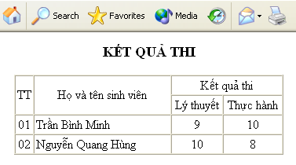

**Lesson 7:** Use Notepad to create the below Web page and save name as **Lesson7.html**



**Lesson 8:** Use Notepad to create the below Web page and save name as **Lesson8.html**

*(Link to all the articles, set the background image for the Website, Create the running text: HTML lesson. Insert background music for the page)*



**Lesson 9:** Use Notepad to create the below Web page and save name as **Lesson9.html**



**Lesson 10:** Use Notepad to create the below Web page and save name as **Lesson10.html**



**Design by Ta Dinh Tien**